Semantic barriers

The Semantic Barriers refers to the **misunderstanding between the sender and receiver** arising due to the different meanings of words.

The semantic barriers usually arise when the information is not in the simple language and contains those **words or symbols that have multiple meanings**. Words like **left** which means to **leave** as well as referring to a **direction**.

* Lack of Common Language
* Poor Vocabulary
* Poor Grammar, Punctuation
* Lack of clarity in the message

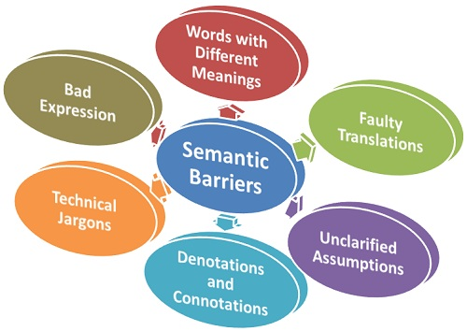

1. **Bad Expression:**The message is not formulated properly and the language used is so difficult that it could be misinterpreted by the recipient. The message is said to be badly expressed if the **wrong words are chosen**, the sentences are not sequenced properly, and there is a frequent **repetition of words or sentences**.
2. **Symbols, or Words with Different Meanings:**There are several words that carry different meanings and often, **people get confused** with these words and interpret these differently due to the difference in their educational and social backgrounds. Such as, the word “Crane” has different meaning as shown in the sentences below:

* **The bird sanctuary is full of cranes.**
* **The builder used a crane to lift heavy steel rods.**
* **The girl has to crane her neck to watch the movie.**

1. **Faulty Translation:**Sometimes, the sender translates the message as per his level of understanding irrespective of the recipient’s comprehension level.
2. **Unclarified Assumptions:**Sometimes the sender creates assumptions about certain things which he feels the receiver must be knowing about it and focus only on the subject matter. But in the case of a special message, if the **assumptions are vague** and unknown to the receiver then the communication might get adversely affected.
3. **Technical jargons:**Often people working in the technical groups such as engineers, production managers, IT managers, etc. use the technical jargons in their communication which is quite difficult for the layman to understand. Thus, the use of technical jargons in communication can act as a barrier.

 semantic barriers lead to misunderstanding of the information and the objective of communication, i.e. for which it was intended, gets disrupted.